## CHERRY IN LINE

**Chapter 5**

**Findings, Results, and Analysis**

5.2 Electrical Audit

5.2.4 Protection coordination study

|  |  |  |  |  |  |  |  |
| --- | --- | --- | --- | --- | --- | --- | --- |
| **Protective Device Settings - Low Voltage Circuit Breaker with Thermal-Magnetic Trip Device** | | | | | | | |
| **LVCB ID** | **Manufacturer** | **Breaker** | | **Thermal** | | **Magnetic (Inst.)** | |
| **Model** | **Size** | **Setting** | **Trip (Amps)** | **Setting** | **Trip (Amps)** |
| CB4 | Fuji Electric | BW400EAG | 250 | Fixed | 250.000 | Fixed | 8 xIn |
| CB9 | Fuji Electric | BW125JAG | 100 | Fixed | 100.000 | Fixed | 8 xIn |
| CB10 | Fuji Electric | BW125JAG | 100 | Fixed | 100.000 | Fixed | 8 xIn |
| CB11 | Fuji Electric | BW32SAG | 32 | Fixed | 32.000 | Fixed | 8 xIn |
| CB12 | Fuji Electric | BW32SAG | 32 | Fixed | 32.000 | Fixed | 8 xIn |
| CB1 | Fuji Electric | BW400EAG | 250 | Fixed | 250.000 | Fixed | 8 xIn |

**CABLE-CIRCUIT BREAKER COORDINATION**

|  |  |  |  |  |  |  |  |  |  |
| --- | --- | --- | --- | --- | --- | --- | --- | --- | --- |
| **Cable / Line ID** | **Protective Device** | | | **Cable Protection** | | | | **Max Fault 3Ph-Amps** | **Refe-rence kV** |
| **Location** | **Device ID** | **Type** | **Pickup Limit** | **Ampacity** | **Damage Curve** | **Condition** |
| Cable1 | Load | CB1 | TM-Magnetic | - | - | Pass | Trip curve protects the damage curve | 2418 | 0.48 |
| TM-Thermal | Pass | Pass | Pass | Therm. Trip 250 A is within 302.7 A = Ampacity |
| Therm. Trip 250 A is within max. limit of 302.7 A = Ampacity x 100% |
| Trip curve protects the damage curve |
| Cable3 | Load | CB4 | TM-Magnetic | - | - | Pass | Trip curve protects the damage curve | 2391 | 0.48 |
| TM-Thermal | Pass | Pass | Pass | Therm. Trip 250 A is within 302.7 A = Ampacity |
| Therm. Trip 250 A is within max. limit of 302.7 A = Ampacity x 100% |
| Trip curve protects the damage curve |

**MCCB COORDINATION**

|  |  |  |  |  |  |  |  |  |  |  |
| --- | --- | --- | --- | --- | --- | --- | --- | --- | --- | --- |
| **Zone ID** | **Zone Type** | **Upstream PD** | **Down**  **stream PD** | **Max Fault** | | **Reference kV** | **Coordination Status** | **Amp Range** | | **Condition** |
| **Type** | **Amp** | **From** | **To** |
| Bus4 | Bus | CB4 | CB9 | 3Ph | 2391 | 0.48 | Alert | 2000 | 2000 | Miscoordination, the time gap is smaller than 0.001 sec margin at I=2000 A, Plot Ref. kV=0.48 |
| L-G |  |  | Warning |  |  | L-G fault coordination is not possible. |
| CB11 | 3Ph | 2391 | 0.48 | Alert | 2000 | 2000 | Miscoordination, the time gap is smaller than 0.001 sec margin at I=2000 A, Plot Ref. kV=0.48 |
| L-G |  |  | Warning |  |  | L-G fault coordination is not possible. |
| CB12 | 3Ph | 2391 | 0.48 | Alert | 2000 | 2000 | Miscoordination, the time gap is smaller than 0.001 sec margin at I=2000 A, Plot Ref. kV=0.48 |
| L-G |  |  | Warning |  |  | L-G fault coordination is not possible. |
| CB10 | 3Ph | 2391 | 0.48 | Alert | 2000 | 2000 | Miscoordination, the time gap is smaller than 0.001 sec margin at I=2000 A, Plot Ref. kV=0.48 |
| L-G |  |  | Warning |  |  | L-G fault coordination is not possible. |

**REMARKS :**

All trip devices are fixed and can not be adjusted. Hence coordination is deemed to be partial since all branch breaker TCC curves crossed the TCC curve of Main breaker on the instantaneous region.

No ground fault protection provided due to the type of breaker supplied. However , this is allowed under the Philippine Electrical Code.

For better coordination, main breaker should be of adjustable and electronic type.

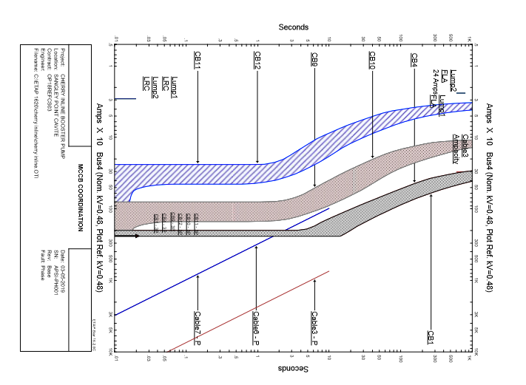

**MISCOORDINATION**